Sleeving Bearing
Impeller rotor( called Rotor for short) and sleeving shaft extend through copper sleeve, which called Sleeving bearing. Motor Stator fixed to the center position, makes stator and rotor an appropriate gap. There must exist gap between the core and bearing, or axis will be locked not to cooperate. Rotor Stator structure portion(called stator for short), After the power input, it will generate induced magnetic field lines between the rotor and stator, drive circuit controls the fan motor running. Traditional fan motors structure, only one impeller stator, stator and drive circuit, contact axis with bearing, the magnetic field line is drive to rotate by magnetic induction.

Advantage of Sleeving Bearing
- Resistant to external impact, caused less damage during transportation;
- Cheap( Compared with ball bearing, large price difference)

Disadvantage of Sleeving Bearing
- The dust in the air is sucked into motor core as rotating fan motor. Which mixed with lubricating oil stored round bearing into sludge, making noise, even refuse to rotate;
- Bearing diameter is easy to wear, service life is shorter;
- Gap between bearing and the shaft is small, motor running activating effect is poor;
- The high temperature gas generated by bearing and shaft friction cannot be excluded as bearing two side oil ring and washers obstruction,which will form nitrogen Nitrogen is easy to blockage in the gap between shaft and bearing, impeding motor running smoothly.

Ball Bearing
Ball bearing working utilize small metal balls for rotation, belongs to point of contact., so rotation is easy to start. With the use of springs to hold the outer metal ring of the ball bearing above, the weight of the entire rotor can sit on the ball bearing, indirectly supported by the springs. Therefore, ball bearings are ideal for use in portable devices with various mounting angles. However, caution should be used to prevent the product from falling and impact damaging the ball bearing, which could lead to noise and shortened product life-time.

Advantage of Ball Bearing:
- Metal ball belongs to contact of points, rotation is easy to start;
- It can be ideals for use in portable devices with various mounting angels( but pay more attention falling);
- Long life span(compared with sleeving bearing;

Disadvantage of Ball Bearing
- Bearing construct is quite fragile and cannot withstand external impact;
- Expensive, cannot compare with sleeving bearing in price;
Ball Bearing is positioned by elasticity of spring, difficult to assemble.

How to Achieve Low Noise
- System Impedance
As known, the area between inlet and outlet ports of a cabinet make up 60% to 80% of the total system impedance. In addition, the greater the air flow is, the higher the noise level is. The higher the total system impedance is, the more air flow is required to provide the necessary cooling. Therefore, system impedance must be reduced to the lowest possible level in order to reduce noise to the least.
- Airflow Obstruction
Obstructions along the path of the flow of the turbulent air generated noise. Thus, obstructions, especially in the critical inlet and outlet area, must be avoided to reduce noise level.
- Fan Speed and Size
Since a high speed fan usually generates greater noise than a low speed fan does, a low speed fan should be tried and used whenever possible. Very often, a larger, slower fan is quieter than a smaller, faster fan while delivering the same air flow.
- Temperature Rise
Air flow is inversely proportional related to allowable temperature rise within a system. A little change in the allowable temperature rise leads to a significant change in air flow required. Therefore, if there is a little compromise to the limit imposed on allowable temperature rise, there will be a considerably less amount of air flow required. As a result, noise is remarkably reduced.
- Vibration
In some cases, the system is light in weight or specified in some certain operating methods, a soft and flexible isolator is highly recommended to avoid the vibration transmission.
- Voltage Variation
Voltage variation affects the level of acoustic noise. When the higher voltage is applied to the fan, the higher vibration is generated due to the increased RPM. Thus, the higher noise level is generated.
- Design Considerations
The design of every component of the fan affects the level of acoustic noise. Low noise levels can be achieved by dimension of winding core, by design of impeller blades and housing and by precision manufacturing and balance.

How to Select Right Fan
All of designers in electric and electronic fields determine the air flow needed to dissipate heat from a given system. A required air flow is determined by knowing the power consumed in the system and the amount of air needed to remove sufficient heat from the system to limit its rise in temperature. In fact, years of experience has shown that the service life of a system is typically decreased by insufficient cooling system. The designer should also know that the price or the sales may be reduced if the service life of the system is not user expected.

To select a right air moving device, one has to consider the objectives in the following list.
- Optimize air flow efficiency
- Minimize size and fit
- Minimize noise
- Minimize power consumption
- Maximize reliability and service life
- Justify the total cost

Fan Function Instructions
1. AS Function(Auto Restart)
The fan can be auto-power supply when blame is locked to protect fan(power-off time is typically 2 to 6seconds). The fan will automatically restart every 2 to 6seconds till the blames force released.
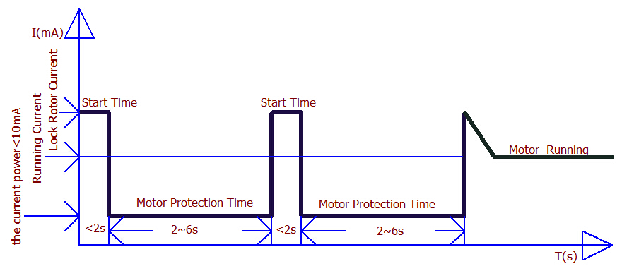

2. CS Function(Constant Speed)
When fan sets speed, it will maintain constant speed even voltage increase between rated voltage to highest voltage to prevent effect fan speed or damage fan.
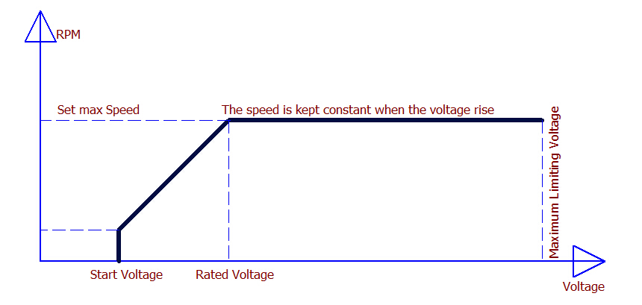

3. OVP Function(Over Voltage Protection)
Fan will be automatically power-off when it exceeds limited voltage to prevent damage to the fan.
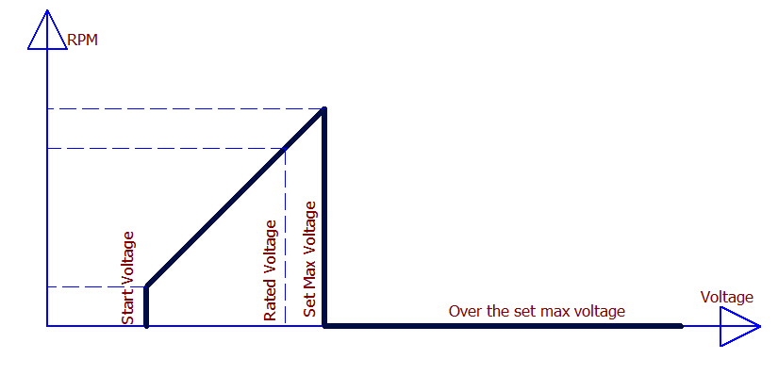

4. SS Function (Soft Start )
When the fan is energized to start, working current and speed from zero gradually increase to rated values to prevent excessive starting current and instantaneous inrush current impact and damage to equipment or power circuits.
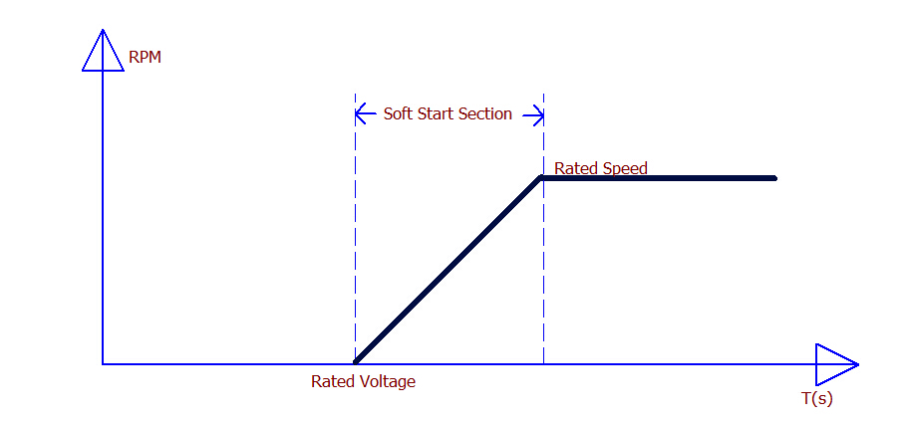

5. LD Function(Low Detection)
The fan set a speed value, when operating speed lower or higher than setted value, the fan output high alarm signal. This feature can be used to big voltage fluctuation fan or when faulty fan speed monitoring and alarm.
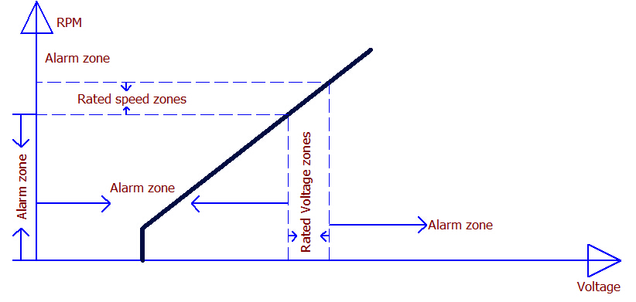

6. FG Function(Frequency Generator)
FG is also known as a Frequency Generator, used to detect fan speed, as details in the following illustration:
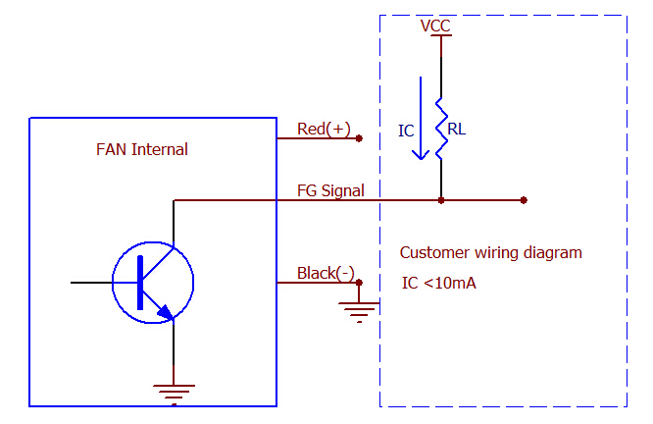

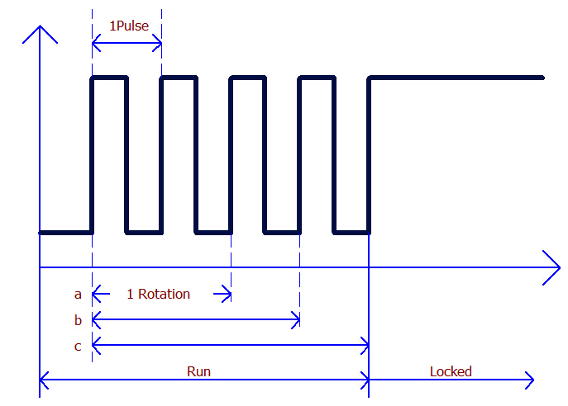

7. RD Function(Rotation Detection)
This function is mainly used for work status detection for the fan, the fan stops operating status and alarm status is detected in two ways:

- RD: When running, output low level signal, when locked, output high level;
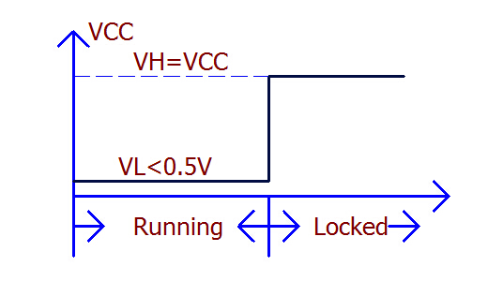

- RDb: When running, output high level signal, when locked, output low level.
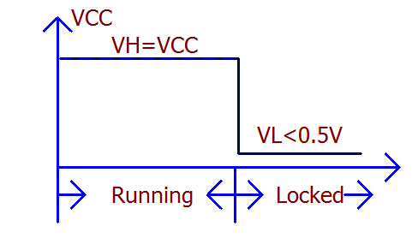

8. PPWM Function(Pulse-Pulse Width Modulation)
Using pulse width control, frequency range 10-40K, speed control principle through a fixed frequency, the frequency changing the duty cycle to adjust the fan speed, speed curve as follows:

(1) PWM1 duty cycle greater, the speed higher. It is full speed when duty cycle is 95%-100%, the minimum speed can be set according customer requirements;
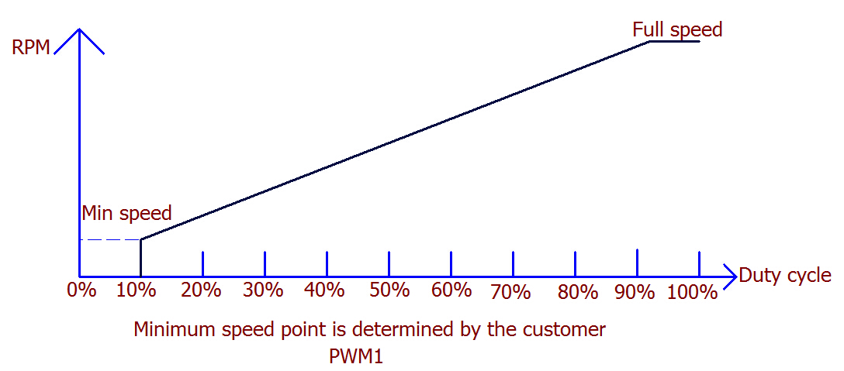

(2) PWM2 duty cycle lower, the speed higher. It is full speed when duty cycle is 0%-5%, the minimum speed can be set according customer requirements.
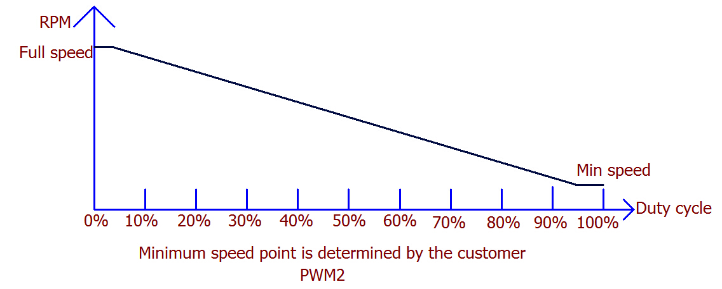

9. VPWM Function(Voltage-Pulse Width Modulation)
By changing the speed signal line voltage level control the speed,the speed range of the general value of a multiple of 5, 05V-10V-15V-25V voltage etc, the governor curve as follows:

(1) VPWM1 corresponding speed signal line voltage lower, fan speed lower, and vice verse. The minimum and maximum speed can be adjusted as customer requirements;
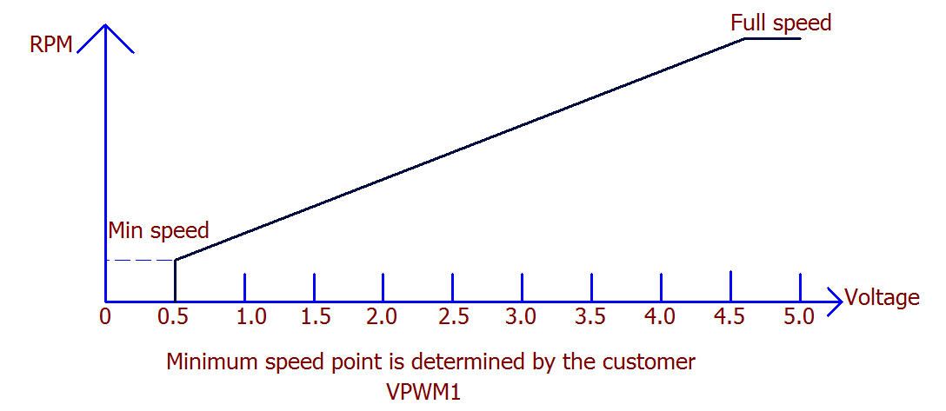

(2) VPWM2 corresponding speed signal line voltage lower, fan speed higher, and vice verse. The minimum and maximum speed can be adjusted as customer requirements;
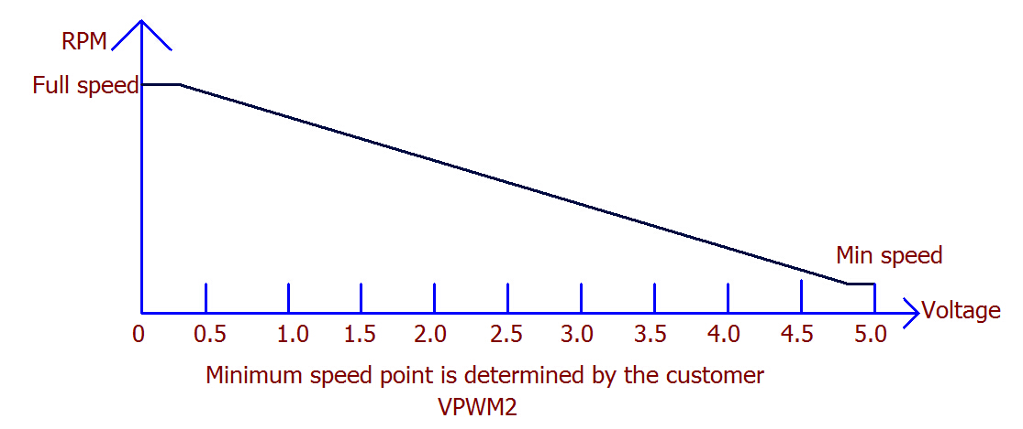

10. TC Function (Temperature Control)
By changing the temperature control fan speed, speed curve as follows:

(1) TC1 Speed mode is linear speed, low and high temperature can be set as customers requirements;
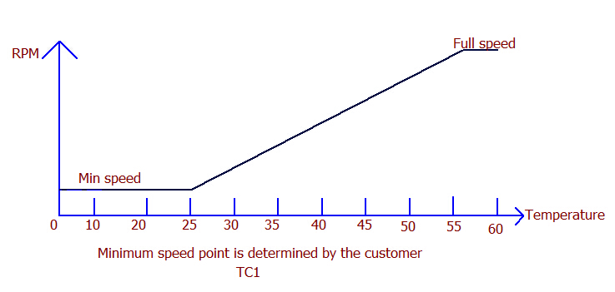

(2) TC2 Speed mode is periodical speed, the fan speed can be divided into several stages;
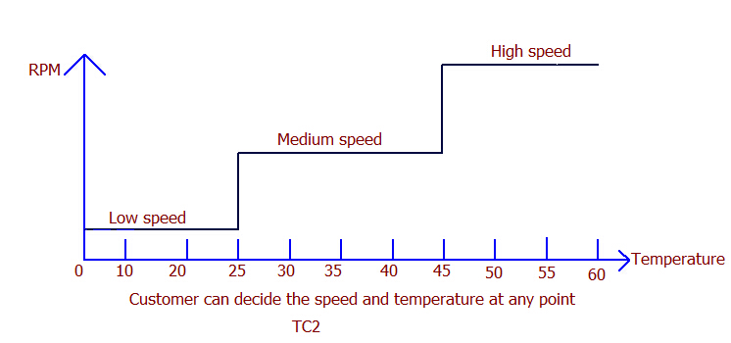

(3) TC3 is used as temperature switch, you can set temperature value to control fan stop.
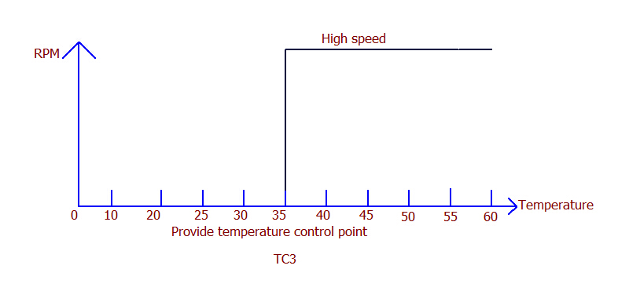

11. RC Function (Resistance control)
External inputs adjustable resistance control fan speed by fan voltage, speed curve as follows:
